SPATIAL LAND-COVER MAPPING OF KOLKATA
USING SENTINEL-2 AND MACHINE LEARNING
A geospatial workflow integrating spectral indices, temporal comparison, H3 aggregation, and supervised classification

Technical Project Report
Study Area: Kolkata, West Bengal, India
Prepared by: ABHILASHA DAS
M.Sc. Data Science

Abstract
This project develops a geospatial workflow for examining land cover in a defined area of Kolkata, India. The work combines Sentinel-2 Level-2A satellite imagery with spectral indices, temporal comparison, a hexagonal spatial grid, reference land-cover labels, and supervised machine-learning classifiers. The area of interest (AOI) is defined by the coordinates 88.25°–88.45° E and 22.50°–22.70° N. The preprocessing notebook prepares a true-colour image from a March 2025 Sentinel-2 scene. The temporal notebook calculates the Normalized Difference Vegetation Index (NDVI), Normalized Difference Water Index (NDWI), and Normalized Difference Built-up Index (NDBI) for three observations dated 3 January, 12 February, and 9 June 2026. The spatial machine-learning notebook aggregates image features to H3 resolution 8 cells and uses ESA WorldCover 2021 to derive majority-class labels. Of 565 grid cells, 540 retain complete features and labels. On a stratified 80:20 split, K-Nearest Neighbours (KNN) achieves 91.7% accuracy and Random Forest achieves 89.8%. These results demonstrate the promise of combining spectral features and spatial aggregation for preliminary land-cover classification. However, the reference labels are imbalanced, the water class has few test observations, the temporal sample is sparse, and the 2021 reference map does not match the 2026 imagery dates. The findings should therefore be interpreted as an exploratory workflow rather than a definitive, independently validated land-cover inventory.
Introduction
Cities are spatially complex. Built-up surfaces, vegetation, water, roads, and mixed land uses can occur within short distances, making land-cover mapping a useful starting point for urban environmental analysis. Satellite imagery provides a consistent way to observe these patterns across an area, while machine learning can help translate spectral measurements into interpretable classes.
This project focuses on a rectangular area of Kolkata, West Bengal. The main aim is to build a reproducible workflow that moves from satellite data retrieval to index calculation, temporal comparison, spatial aggregation, and land-cover classification. Rather than treating the image as one large raster, the workflow also summarises pixels within H3 hexagonal cells. This creates a spatial unit that can support mapping and later integration with other urban datasets.
The project has four practical objectives. First, retrieve and crop Sentinel-2 imagery to the AOI and prepare a visual composite. Second, calculate NDVI, NDWI, and NDBI and compare selected dates. Third, aggregate spectral information and reference land-cover classes to H3 cells. Finally, train and compare KNN and Random Forest classifiers and generate a map of predicted land cover.
The three notebooks represent related stages, but they do not form a perfectly continuous time series. The preprocessing notebook selects a scene from March 2025, whereas the index and classification notebooks use a scene from June 2026. The report keeps these dates distinct rather than treating them as one harmonised image collection.
Literature Review
Satellite remote sensing and spectral indices
Sentinel-2 provides multispectral observations at several spatial resolutions and is widely used for vegetation, water, and land-surface analysis. Spectral indices combine selected bands into ratios that make certain surface properties easier to compare. NDVI contrasts near-infrared and red reflectance and is commonly used as an indicator of vegetation greenness. NDWI, in the form implemented here, contrasts green and near-infrared bands to highlight water-related spectral responses. NDBI contrasts short-wave infrared and near-infrared reflectance and is often used to investigate built-up surfaces. These indices are useful indicators, not perfect semantic labels: mixed pixels, shadows, materials, seasonality, and atmospheric conditions can produce overlapping values.
Spatial aggregation and land-cover classification
A regular spatial grid reduces the complexity of pixel-level data and makes it easier to compare locations using consistent units. H3 is a hierarchical hexagonal indexing system that assigns geographic locations to cells at a chosen resolution. In this project, spectral values are summarised within H3 cells, and the resulting feature table is used for classification.
KNN classifies a sample using the labels of nearby observations in feature space. Its behaviour depends on feature scaling and the number of neighbours. Random Forest combines many decision trees and can represent nonlinear relationships between spectral variables. Both methods are established baseline classifiers. Their reported performance depends on the quality and independence of the reference labels, the train-test design, and class balance. In this project, ESA WorldCover supplies reference categories, so the model is learning to reproduce a reclassified reference product rather than labels collected through independent field validation.
Methodology
Study area and satellite data
The AOI is a rectangular polygon with bounds [88.25, 22.50, 88.45, 22.70] in EPSG:4326. It is saved as a GeoPackage for reuse by later notebooks. Sentinel-2 Level-2A scenes are discovered through the Microsoft Planetary Computer STAC API. The preprocessing notebook searches from 1 January to 31 March 2025 with a cloud-cover threshold below 20% and selects the first returned item, dated 29 March 2025. The later notebooks search 2026 imagery with a cloud-cover threshold below 30%; the selected single-date scene is 9 June 2026.
Band preparation and indices
The workflow reads the blue (B02), green (B03), red (B04), near-infrared (B08), and short-wave infrared (B11) bands. The preprocessing notebook converts B02, B03, and B04 digital values to reflectance by dividing by 10,000 and stretches the 2nd to 98th percentiles to build an RGB display. The later index workflow resamples B11 from its native 20 m grid to the 10 m B04 reference grid using nearest-neighbour resampling. This enables pixel-wise index calculations, although resampling does not create new spatial detail in the original 20 m band.
The indices are calculated as follows:
$$NDVI=\frac{(B08 - B04) }{(B08 + B04)}$$
$$NDWI=\frac{(B03 - B08)}{(B03 + B08)}$$
$$NDBI=\frac{(B11 - B08) }{(B11 + B08)}$$
The functions return NaN where the denominator is zero. The preprocessing notebook also reads the Sentinel-2 Scene Classification Layer and checks classes associated with cloud shadow, medium- and high-probability cloud, cirrus, and snow/ice. No pixels from those selected classes were found in that scene. The notebook creates a cloud mask, but the later index notebook does not explicitly apply that mask to the index arrays.
Temporal comparison
The temporal notebook queries 2026 scenes and finds 46 candidates. It selects the first, middle, and last items after chronological sorting. The resulting dates are 3 January, 12 February, and 9 June 2026. All bands are aligned to the first observation's 10 m grid. The three index rasters are stacked into arrays with dimensions (3, 2080, 2076), and a pixel-wise median composite is produced for each index.
For NDVI change, the notebook subtracts the first observation from the last observation. It then defines pixels with a change greater than 0.1 as greening and pixels with a change below −0.1 as browning. These thresholds are operational choices made in the code; they are not presented as statistically validated ecological thresholds.
H3 grid and feature engineering
The spatial notebook uses H3 resolution 8 to cover the AOI, producing 565 hexagonal cells. For each cell, zonal statistics summarise mean and standard deviation for NDVI, NDWI, and NDBI, alongside the valid pixel count. A separate feature extraction step calculates mean values for B02, B03, B04, B08, and B11, plus mean NDVI, NDWI, and NDBI. These eight mean features form the predictor set for machine learning.
Reference labels and models
ESA WorldCover 2021 is queried through the STAC API and cropped to the AOI. Its native categories are regrouped into four project classes: built-up becomes Urban; tree cover, shrubland, grassland, cropland, and mangroves become Vegetation; water and wetland become Water; and bare or sparse vegetation becomes Other. Each H3 cell receives the class with the largest number of WorldCover pixels within its boundary. In the observed label distribution, the retained H3 labels are Urban, Vegetation, and Water; no other class remains as a majority label in the final model table.
The spectral feature table is joined to the label table by H3 identifier. Missing rows are dropped, leaving 540 records. The data are split into 80% training and 20% testing and stratification by class. KNN uses five neighbours and standardised features. Random Forest uses 100 trees. The code fits Random Forest on the unscaled feature values, which is acceptable for tree-based models because they do not rely on distance calculations in the same way as KNN.
Data Description
Datasets and variables
Sentinel-2 Level-2A imagery is the primary spectral source. The single-date index arrays are 2,080 × 2,076 pixels at a nominal 10 m grid. The three-date data cube contains three observations for each of NDVI, NDWI, and NDBI. The AOI is stored in `kolkata_aoi.gpkg`.
ESA WorldCover 2021 supplies categorical reference data at 10 m nominal resolution. The cropped AOI raster is 2,400 × 2,400 pixels. Two additional raster files are read in the spatial notebook: `IND_DUG_2026_GRID_L2_R2025A_v1.tif` and `IND_DUG_2026_GRID_L1_R2025A_v1.tif`. Their cropped windows are 24 × 27 pixels, with observed values of 30 and 3 respectively. These layers are inspected but are not included in the final model's eight predictor columns. Their interpretation should be confirmed from the corresponding product documentation before they are used analytically.
The final machine-learning table has 540 rows and 10 columns: an H3 identifier, eight spectral features, and one target label. The class counts are 328 Urban, 175 Vegetation, and 37 Water. The train-test split contains 432 training records and 108 test records. In the test set, the class supports are 66 Urban, 35 Vegetation, and 7 Water.
Preprocessing decisions
The main transformations are spatial cropping, reflectance scaling for the RGB image, percentile stretching for display, band resampling and alignment, spectral-index calculation, zonal aggregation, class recoding, merging by H3 ID, and removal of incomplete rows. StandardScaler is fitted only on the training features and then applied to the test features for KNN, which avoids using test-set statistics during scaling.
A methodological detail deserves attention. The feature-extraction code uses B11 values with the B04 profile for zonal statistics. The notebook has already created a resampled B11 array in the earlier index workflow, but the feature-extraction cell's displayed dictionary references `band_11`. For spatially consistent feature extraction, the resampled B11 array and its reference transform should be used explicitly. This should be checked in the implementation before the analysis is treated as final.
Notebook workflow
The first notebook establishes the AOI, connects to the STAC catalogue, searches for low-cloud Sentinel-2 scenes, and defines a reusable `read_band` function. That function transforms the AOI to the raster coordinate system, calculates a raster window, reads only the intersecting pixels, and updates the output profile to match the cropped array. It then reads the visible bands, converts them to reflectance, stretches the bands, and creates an RGB composite. The Scene Classification Layer is checked for cloud-related categories, and the AOI is saved as a GeoPackage.
The second notebook imports the reusable band reader and defines three index functions and a resampling function. It calculates indices for one selected scene, creates maps, then builds a small temporal stack from three selected dates. A reference raster profile is used to align observations onto the same grid. Median composites and an NDVI difference raster are calculated, and the notebook counts pixels that cross the selected positive or negative change thresholds.
The third notebook converts the AOI to H3 resolution 8, computes zonal statistics, reads and recodes WorldCover classes, assigns each cell a majority label, and constructs the feature table. It then performs a stratified train-test split, scales the KNN predictors, trains KNN and Random Forest, reports accuracy and class-level precision, recall, and F1-score, plots confusion matrices, and applies the trained KNN model to all feature-complete cells. Finally, it saves the predictions as a CSV and GeoPackage.
Libraries and their roles
NumPy and pandas support array operations and tabular processing. GeoPandas and Shapely manage AOI and H3 geometries. Rasterio reads and reprojects raster data, while rasterstats computes zonal summaries. pystac-client searches the STAC catalogue and planetary-computer signs asset links. H3 creates the hexagonal grid. Matplotlib and Seaborn create maps and diagnostic plots. Scikit-learn provides scaling, train-test splitting, KNN, Random Forest, confusion matrices, accuracy, and classification reports.

Results and Analysis
Image preparation
The preprocessing notebook selected the Sentinel-2 scene dated 29 March 2025 and produced an RGB image with dimensions 2,080 × 2,076 × 3. The selected scene's catalogue cloud-cover value is approximately 0.0012 in the returned metadata field. The SCL array has dimensions 1,040 × 1,038 and contains none of the explicitly masked classes, so the computed cloud/shadow count is zero. This supports the notebook's clear-scene selection, but it does not prove that every pixel is free from haze, shadow, or other radiometric artefacts.
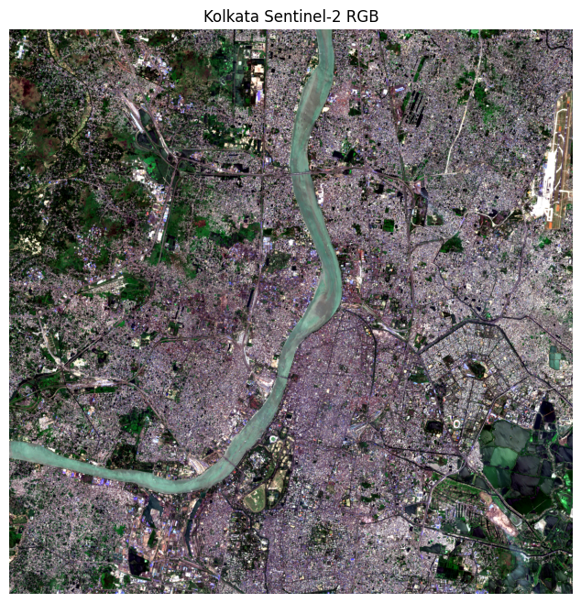
The image shows the cropped AOI as a natural-colour composite. Urban surfaces, vegetation, water bodies, and large spatial patterns should be described cautiously because RGB appearance alone is not a validated land-cover classification.
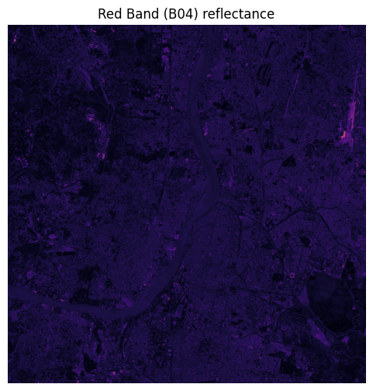
The single-band image illustrates spatial variation in red reflectance. Its grayscale or colour-ramped appearance reflects pixel values, not land-cover classes.
Spectral index values
For the 9 June 2026 scene, the notebook reports NDVI from −0.55 to 0.78 with a mean of 0.20; NDWI from −0.68 to 0.64 with a mean of −0.19; and NDBI from −0.76 to 0.69 with a mean of −0.04. These are broad distributions, with both positive and negative values. The mean NDVI is consistent with a mixture of vegetated and non-vegetated surfaces across the AOI. The negative mean NDWI suggests that the green-minus-near-infrared contrast is negative on average under the chosen formulation. The NDBI mean close to zero indicates that the average short-wave-infrared and near-infrared contrast is modest. None of these means should be interpreted as direct estimates of land-cover proportions.

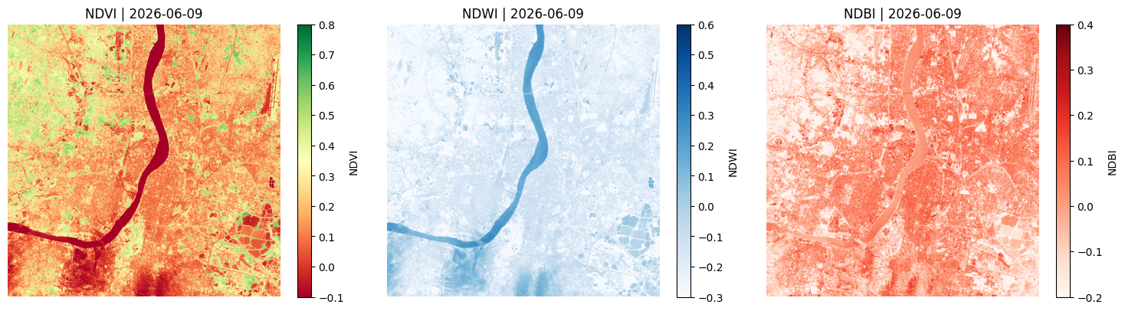
The three panels use their own colour bars and clearly state the index names and date. NDVI should emphasize relative vegetation response, NDWI the green-to-near-infrared contrast, and NDBI the short-wave-infrared-to-near-infrared contrast. The description should note that index values overlap across surface types.
Temporal patterns and NDVI change
The three selected observations are 3 January, 12 February, and 9 June 2026. The median NDVI composite spans −0.228 to 0.612. Between the first and last observations, the NDVI change raster has a minimum of −0.735, a maximum of 0.716, a mean of 0.056, and a standard deviation of 0.093. Using the notebook's thresholds, 1,230,283 pixels, or 28.5% of valid pixels, show an NDVI increase greater than 0.1. A further 159,086 pixels, or 3.7%, show a decrease below −0.1.
The positive mean difference and larger count of pixels above the positive threshold suggest that increases in NDVI are more widespread than decreases between the two selected dates. However, this is not sufficient evidence of long-term urban greening. The observations are sparse, the dates span different seasonal conditions, and the comparison uses only the first and last images. Changes may reflect seasonal vegetation cycles, moisture, crop conditions, residual atmospheric effects, or land-cover change.
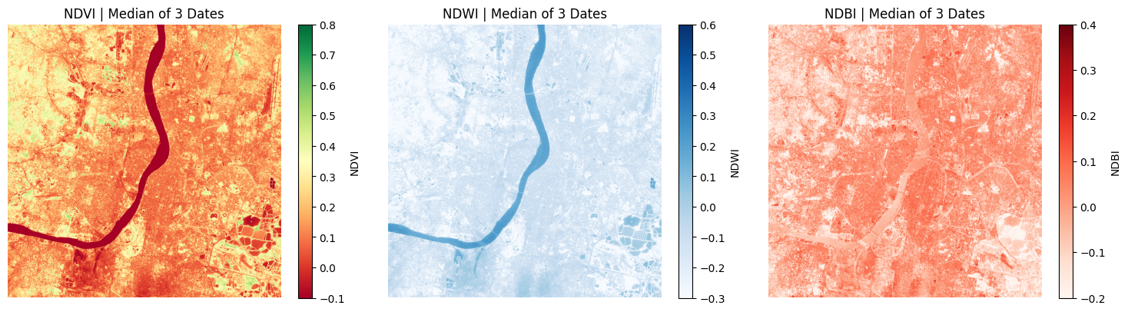
The panels represent the pixel-wise median across 3 January, 12 February, and 9 June. The caption should state that three dates are not a dense time series and that the median is used to reduce the influence of unusually high or low observations.
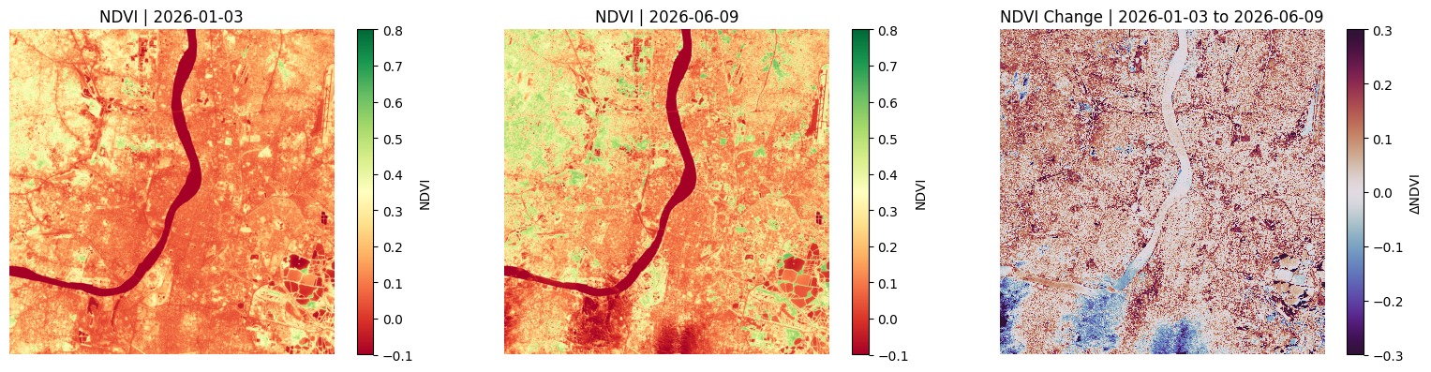
The first two panels use a consistent NDVI scale. The change panel should use a diverging colour scheme centred near zero so that increases and decreases are distinguishable. The mapped pattern should be discussed as observed index change, not as confirmed ecological recovery or degradation.
H3 grid and spatial dataset
H3 resolution 8 produced 565 cells across the AOI. In one aggregation step, 540 cells had valid NDVI pixel counts. The subsequent feature-and-label join also yielded 540 complete records. The reference label distribution before dropping incomplete feature records was 343 Urban, 185 Vegetation, and 37 Water cells. After the join and removal of incomplete rows, the final distribution was 328 Urban, 175 Vegetation, and 37 Water. Urban is the largest class, while Water is the smallest.
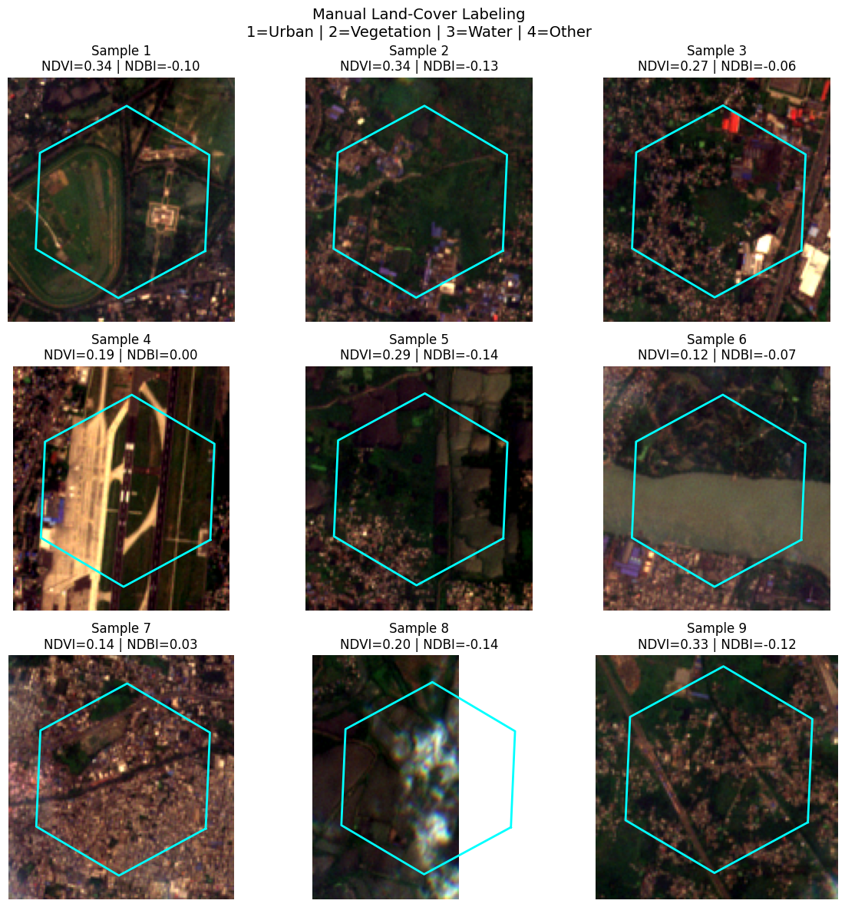
The figure show the AOI boundary and the intersecting H3 cells. It should communicate the analysis unit used to summarise satellite pixels and provide context for the final classification map.
A small set of selected hexagons should be shown over image chips. The figure can explain how the spatial cells relate to the underlying image and why each cell summarises a mixture of pixels.

Model performance
KNN achieved 91.7% accuracy on the 108-record test set, compared with 89.8% for Random Forest. KNN therefore performed better on overall accuracy in this split, although the difference is modest and does not establish that KNN will generalise better under other sampling designs.
For KNN, Urban precision, recall, and F1-score are 0.91, 0.97, and 0.94. Vegetation scores are 0.94, 0.86, and 0.90. Water scores are 0.83, 0.71, and 0.77. Random Forest records : Urban scores of 0.94, 0.91, and 0.92; Vegetation scores of 0.86, 0.91, and 0.89; and Water scores of 0.71, 0.71, and 0.71. Both models perform least reliably on Water, which has only seven test examples. The weighted averages are strongly influenced by the larger Urban class.
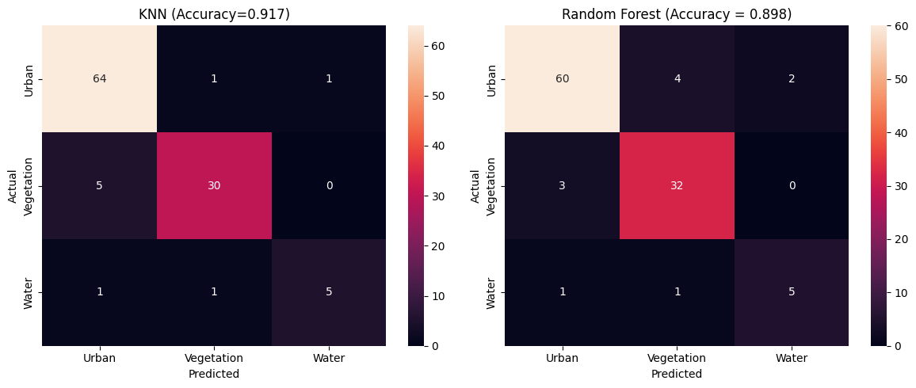
The two matrices show actual classes on the vertical axis and predicted classes on the horizontal axis. The KNN panel should be labelled with 91.7% accuracy and the Random Forest panel with 89.8%. Off-diagonal cells identify class confusions; these are especially important for evaluating the small Water class.
The map should display predicted Urban, Vegetation, and Water cells with a clear legend and AOI outline. It represents KNN predictions for feature-complete H3 cells, not a ground-truth map. The output table reports 347 Urban, 160 Vegetation, and 33 Water predictions.

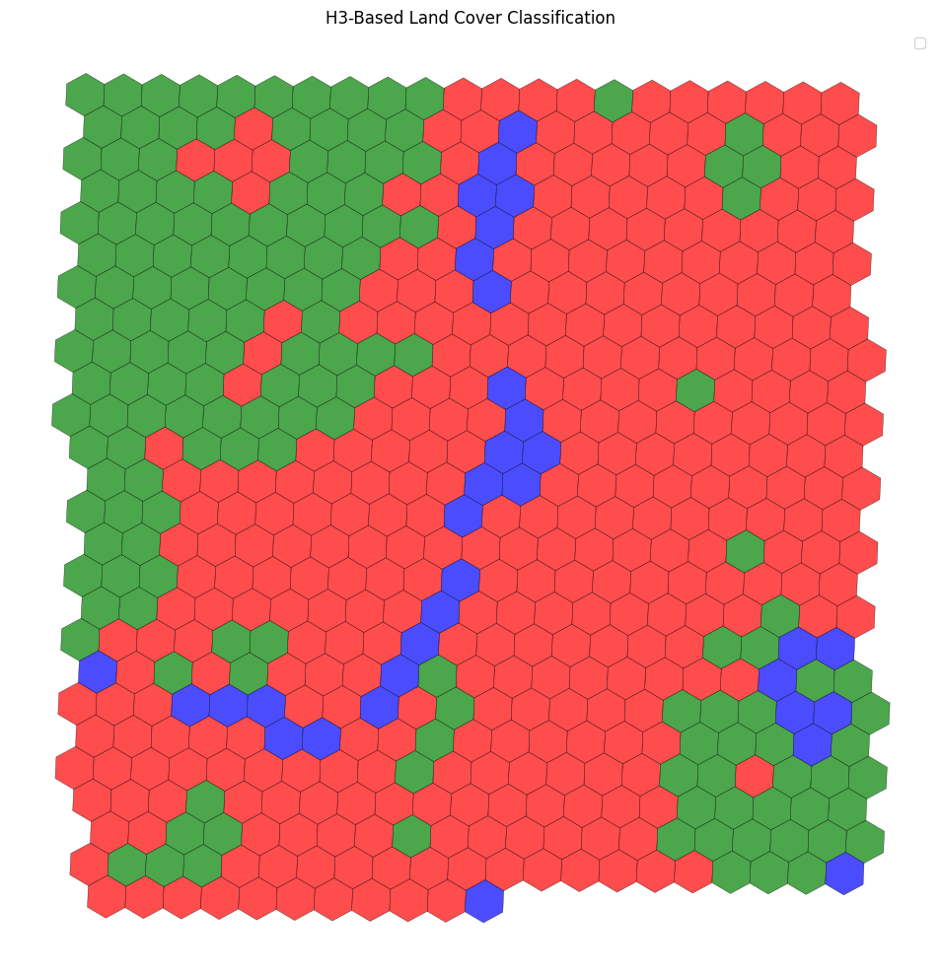
Applying the KNN classifier to all feature-complete cells produced 347 Urban predictions, 160 Vegetation predictions, and 33 Water predictions. This distribution differs from the final reference-label distribution, which contains 328 Urban, 175 Vegetation, and 37 Water cells. Such differences can arise from the model's learned decision boundaries and should be examined spatially and against independent reference data before being used for planning.

Discussion
The main strength of the workflow is its end-to-end structure. It starts with remotely sensed data, calculates interpretable spectral indices, adds a temporal comparison, transforms pixel data into spatially meaningful units, and evaluates two baseline classifiers. The use of H3 makes the output easier to join to other cell-based indicators. The notebooks also preserve geospatial outputs in GeoPackage and CSV formats, which supports reuse.
The results suggest that the spectral features contain useful information for distinguishing the three retained land-cover classes. KNN's test accuracy is high in this particular split, and its Urban and Vegetation F1-scores are strong. Yet overall accuracy alone is not enough. The Water class is underrepresented, and seven test observations provide a very uncertain basis for judging water-class performance. A stratified split preserves class proportions, but it does not solve the imbalance or guarantee spatial independence.
There are several limitations to address. First, WorldCover 2021 labels are compared with Sentinel-2 imagery from 2026, so real land-cover change between the reference and image dates may appear as model error. Second, the model is evaluated against labels derived from WorldCover rather than independent field observations. Third, random cell splitting can place neighbouring cells in both training and testing sets, potentially inflating performance because nearby locations often have similar spectral characteristics. Spatial block validation would offer a more stringent test.
The temporal analysis is exploratory. Only three dates are used, and the final selected date is 9 June even though the query interval extends to 4 September 2026. The result should be described as a three-observation comparison rather than a comprehensive annual trend. In addition, the cloud mask is computed in the preprocessing notebook but is not explicitly propagated through the later index calculations. The model's feature extraction should also be checked to ensure that the resampled B11 band and matching transform are used consistently.
Finally, the additional urbanisation rasters are inspected but not integrated into the model. Their cropped values are constant within the AOI window in the displayed outputs, so they would not provide useful within-AOI discrimination in their current form. Product metadata and intended interpretation should be checked before including them in future analysis.

Conclusion and Future Work
This project demonstrates a practical geospatial machine-learning pipeline for land-cover mapping in Kolkata. Sentinel-2 bands were used to calculate NDVI, NDWI, and NDBI; three observations were aligned to a common grid to examine index change; and H3 cells were used to aggregate spectral features and reference classes. On the current stratified test split, KNN achieved 91.7% accuracy and Random Forest achieved 89.8%. KNN was the stronger baseline by overall accuracy, but performance on Water was weaker and less certain than performance on the more common classes.
The next stage should strengthen validation before drawing policy conclusions. Use a larger and more balanced set of reference samples, verify labels against recent high-resolution imagery or field observations, and test models with spatially separated training and test blocks. Extend temporal analysis with regularly spaced, cloud-screened observations across multiple seasons and years. Apply the SCL cloud/shadow mask consistently, verify band alignment and resampling, and report per-class precision, recall, F1-score, and uncertainty alongside overall accuracy. Further models, such as gradient-boosted trees or support vector machines, could be evaluated using the same validation design. The workflow could then be extended to monitor urban expansion, vegetation distribution, and water-related land-cover patterns over time.
References
European Space Agency (ESA). (n.d.). Sentinel-2 mission and MultiSpectral Instrument (MSI) documentation. https://sentinels.copernicus.eu/web/sentinel/missions/sentinel-2
European Space Agency (ESA). (2021). ESA WorldCover 10 m 2021 v200. https://worldcover2021.esa.int/
Microsoft Planetary Computer. (n.d.). STAC API and data catalogue. https://planetarycomputer.microsoft.com/
Uber Technologies. (n.d.). H3: A hexagonal hierarchical geospatial indexing system. https://h3geo.org/
McFeeters, S. K. (1996). The use of the Normalized Difference Water Index (NDWI) in the delineation of open water features. International Journal of Remote Sensing, 17(7), 1425–1432.
Rouse, J. W., Haas, R. H., Schell, J. A., & Deering, D. W. (1974). Monitoring vegetation systems in the Great Plains with ERTS. NASA SP-351, 309–317.
Zha, Y., Gao, J., & Ni, S. (2003). Use of normalized difference built-up index in automatically mapping urban areas from TM imagery. International Journal of Remote Sensing, 24(3), 583–594.
Breiman, L. (2001). Random Forests. Machine Learning, 45, 5–32.
Pedregosa, F., et al. (2011). Scikit-learn: Machine Learning in Python. Journal of Machine Learning Research, 12, 2825–2830. https://jmlr.org/papers/v12/pedregosa11a.html
Gillies, S., et al. (n.d.). Rasterio: Geospatial raster I/O for Python. https://rasterio.readthedocs.io/
GeoPandas developers. (n.d.). GeoPandas documentation. https://geopandas.org/
NumPy developers. (n.d.). NumPy documentation. https://numpy.org/doc/
pandas development team. (n.d.). pandas documentation. https://pandas.pydata.org/docs/
Shapely developers. (n.d.). Shapely documentation. https://shapely.readthedocs.io/
Python Software Foundation. (n.d.). Python documentation. https://docs.python.org/3/

